***Final Testing***

**Index**

**1 - Login Form**

Valid Teacher Login

Valid Technician Login

Valid Administrator Login

Invalid Login

**2 – Change Password Form**

Invalid Password Change

Valid Password Change

Result

**3 – View Entries Form**

View All

View Unresolved

View Resolved

**4 – Log Fault Form**

Invalid Fault Logged

Valid Fault Logged

New Fault Results

**5 – Administrator Form**

Edit Room

* Add Room
* Delete Room
* Delete Room Result
* Modify Room
* Modify Room Result

Edit Users

* Add User
* Add User Result
* Remove User

Edit Computers

* Add Computer
* Add Computer Result
* Remove Computer
* Remove Computer Result
* Modify Computer
* Modify Computer Result

**6 – Technician Form**

View All

View Unresolved

View Resolved

View by Room

View by Computer

**7 – Inactive Faults Form**

Current Faults

View Inactive Faults

**8 – Fault Count Form**

View Faults per Room

**9 – Update Status Form**

Valid Status Update

Result

**10 – Resolve Form**

Resolve Selection

Valid Resolve

Result

- Before

- After

**Images**

**Login Form**

Valid Teacher Login

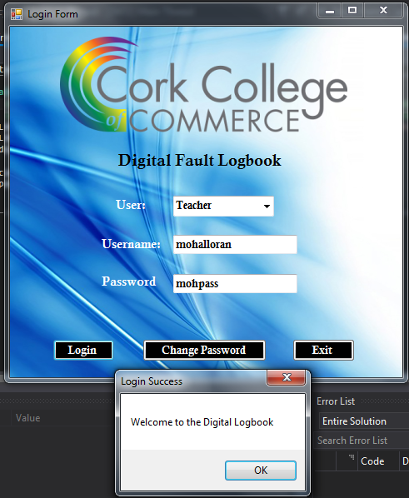

Valid Technician Login

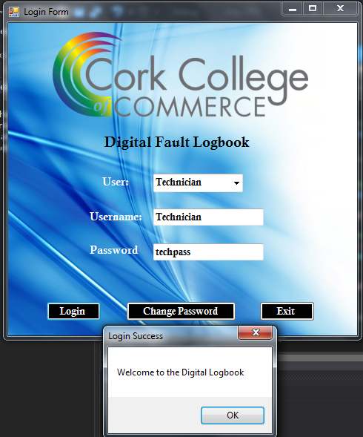

Valid Administrator Login

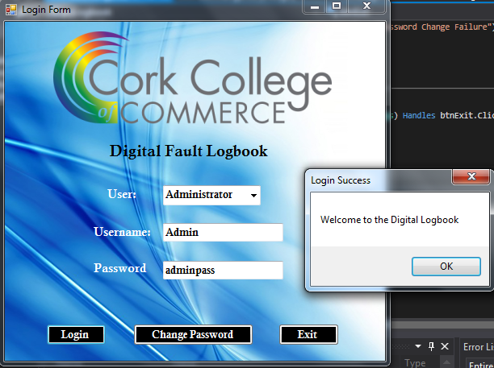

Invalid Login

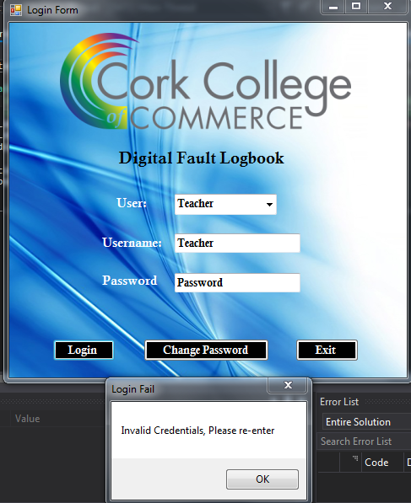

**Change Password Form**

Invalid Password Change

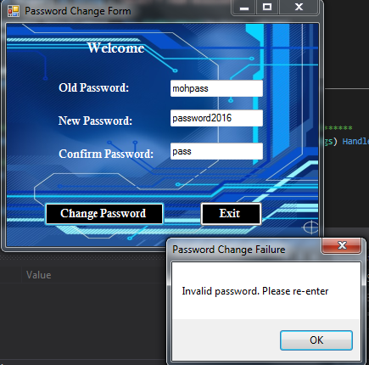

Valid Password Change

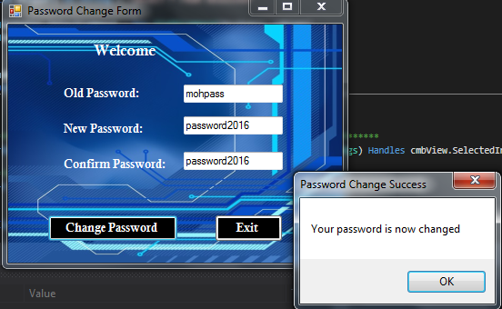

Result

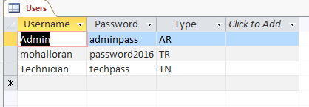

**View Entries Form**

View All

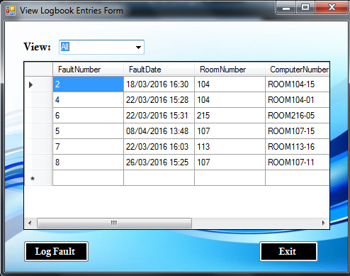

View Unresolved

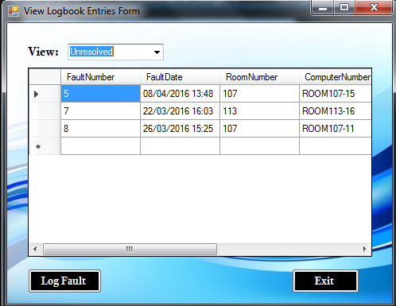

View Resolved

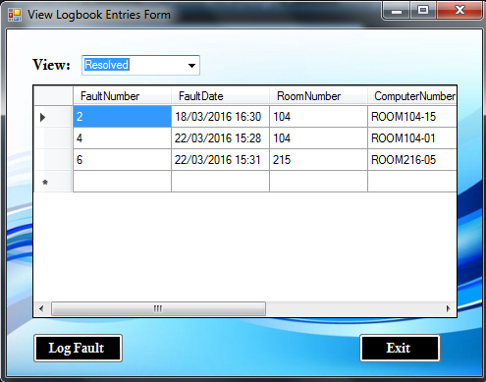

**Log Fault Form**

Invalid Fault Logged

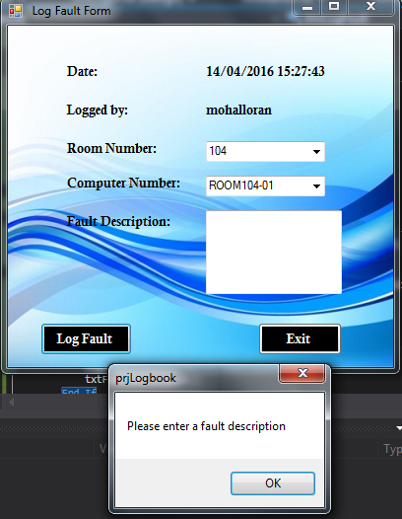

Valid Fault Logged

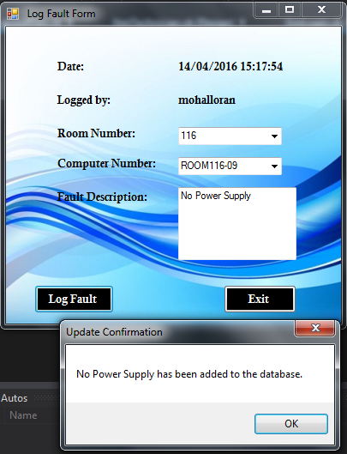

New Fault Results

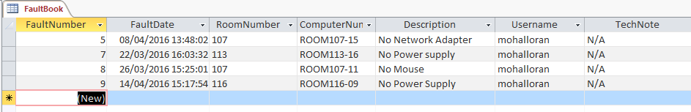

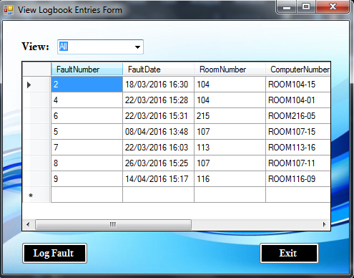

**Administrator Form**

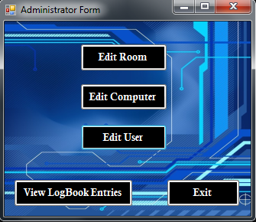

Edit Room

Add Room

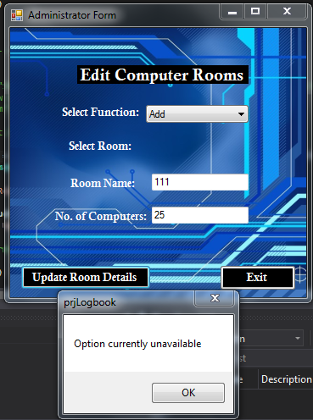

Delete Room

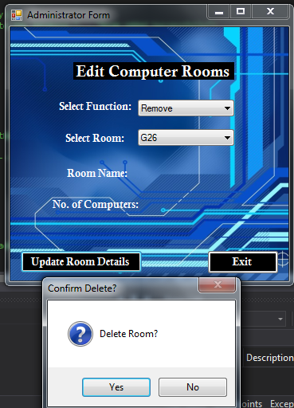

Delete Room Result

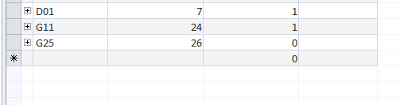

Modify Room

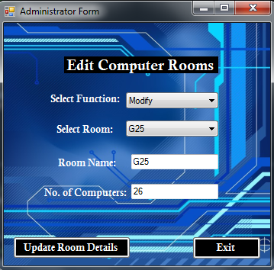

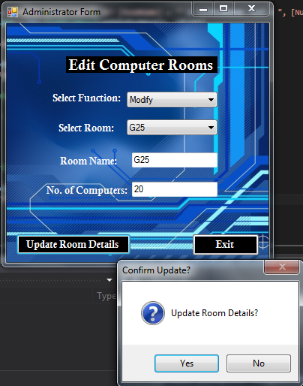

Modify Room Result

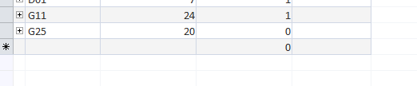

Edit Users

Add User

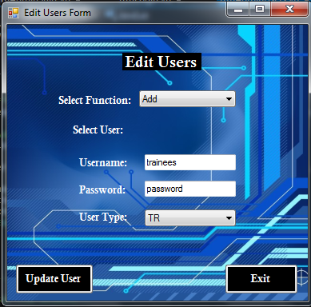

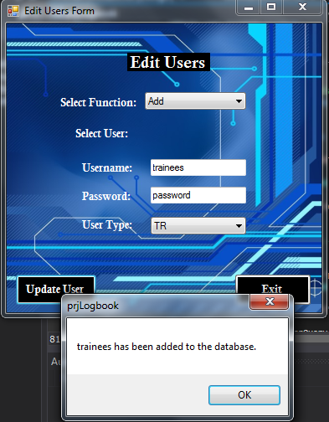

Add User Result

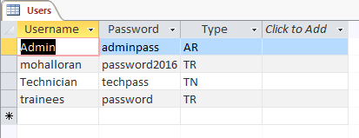

Remove User

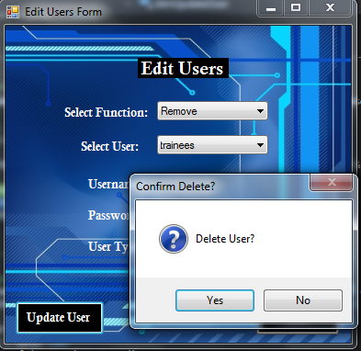

Edit Computers

Add Computer

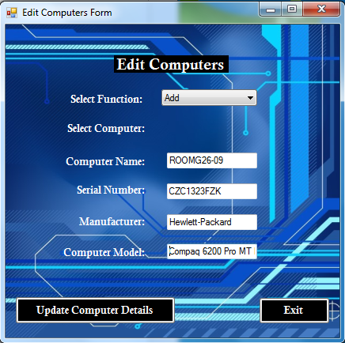

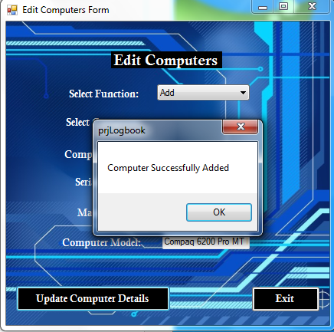

Add Computer Result

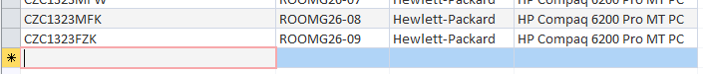

Remove Computer

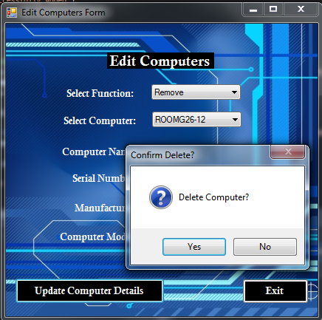

Remove Computer Result

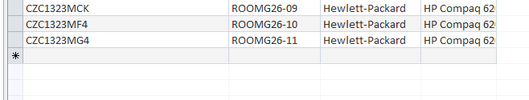

Modify Computer

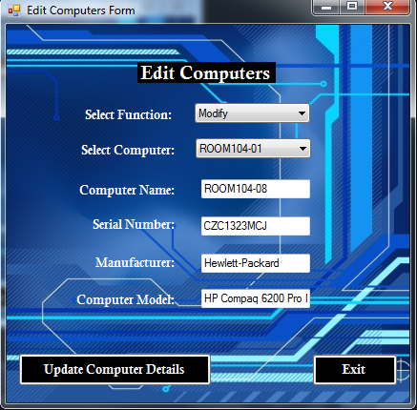

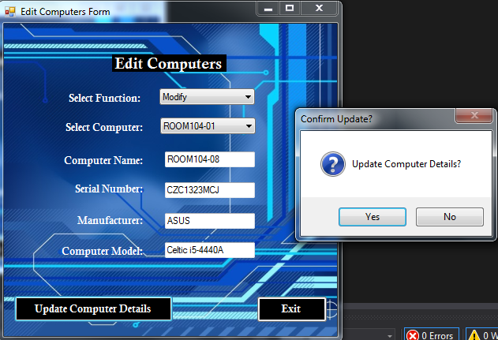

Modify Computer Result

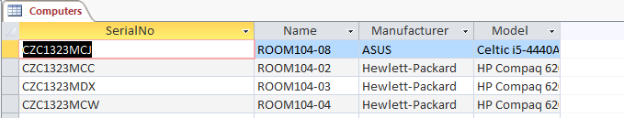

**Technician Form**

View All

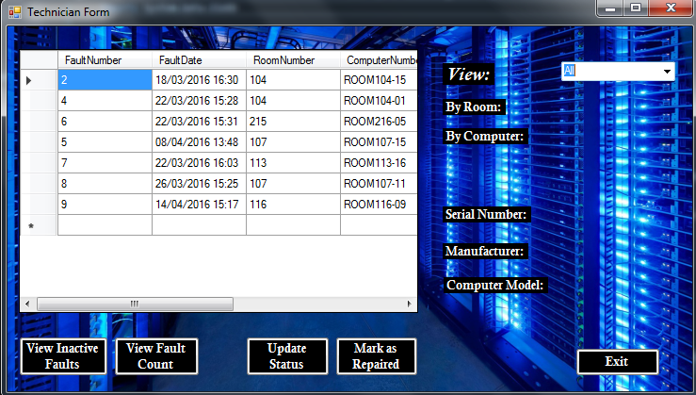

View Unresolved

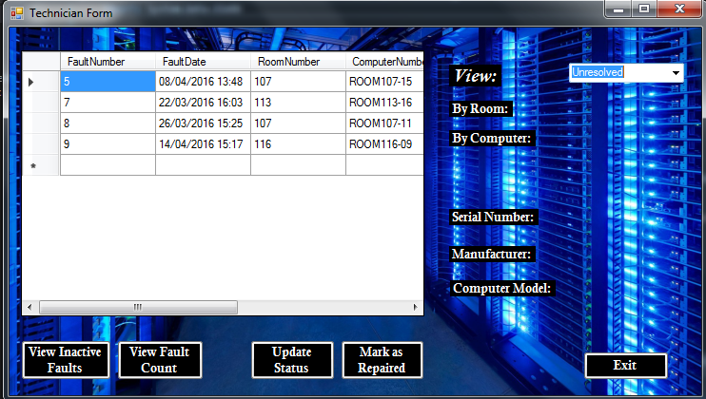

View Resolved

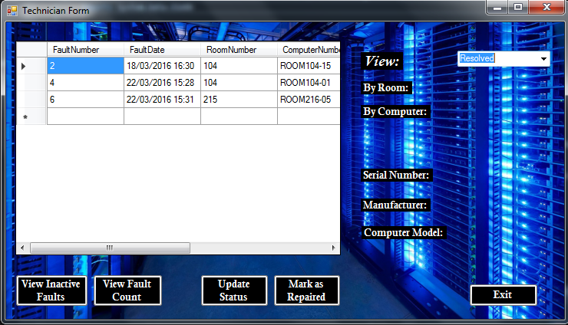

View by Room

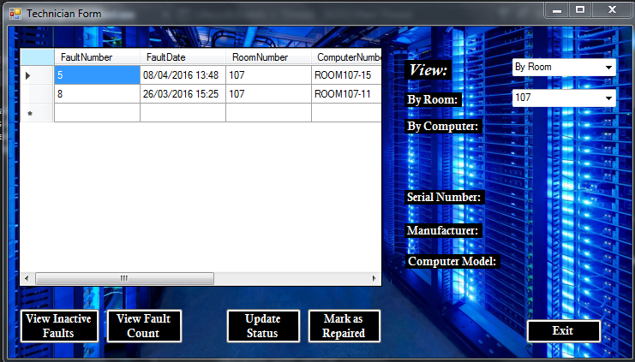

View by Computer

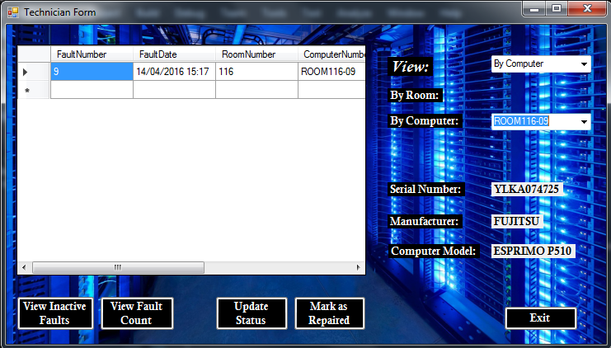

**Inactive Faults Form**

Current Faults

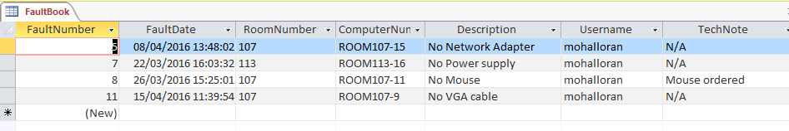

View Inactive Faults

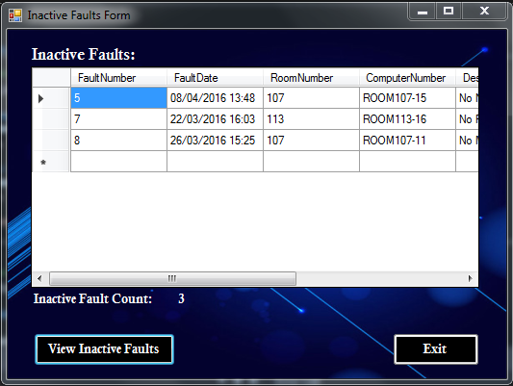

**Fault Count Form**

View Faults per Room

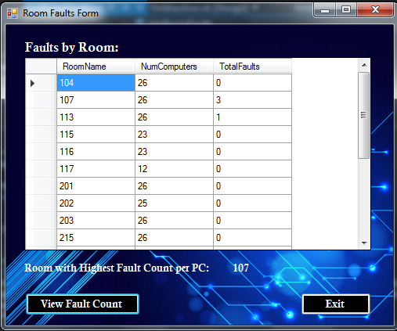

**Update Status Form**

Valid Status Update

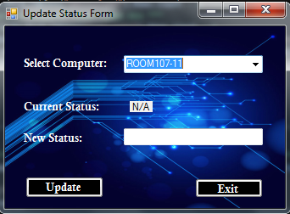

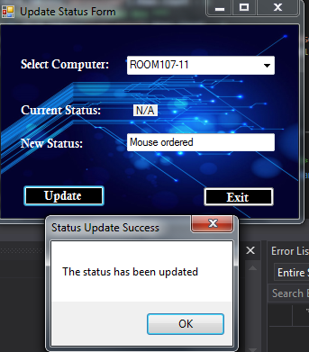

Result

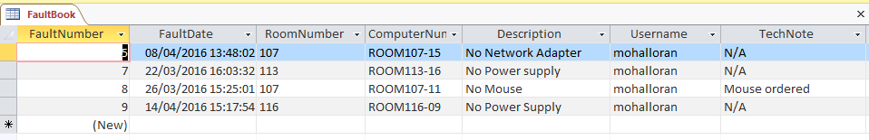

**Resolve Form**

Resolve Selection

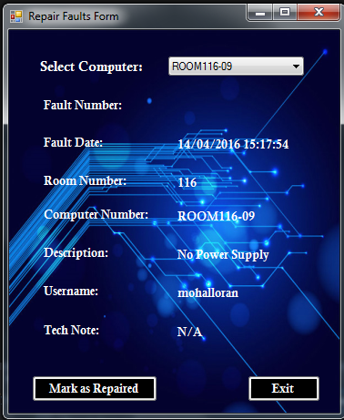

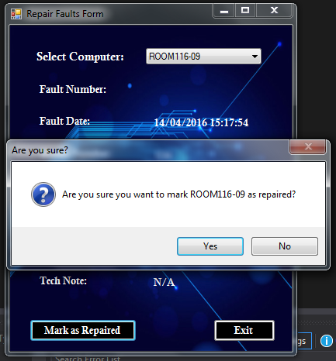

Valid Resolve

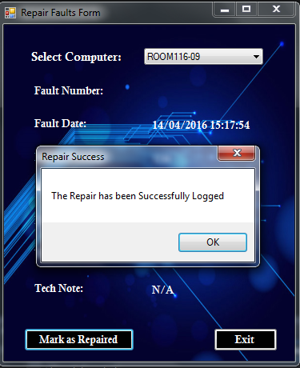

Result

Before

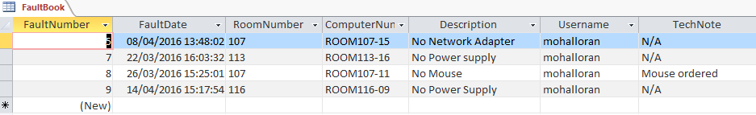

After

